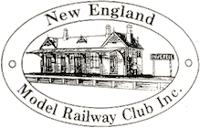

**Partners Day Programme**

**Saturday 16th November 2024, 8:30am – 4:30pm**

An invitation to the partners of attendees to the New England Model Railway Club Convention to enjoy a full day of sights and flavours in the New England region. There are many great places to see, and we have selected a few fine locations to visit as part of this year’s partners tour. A chartered bus will depart the Armidale Bowling Club at 8:30am to transport you to each of the days planned activities and return to the club around 4:30pm.

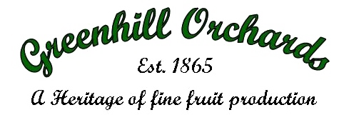 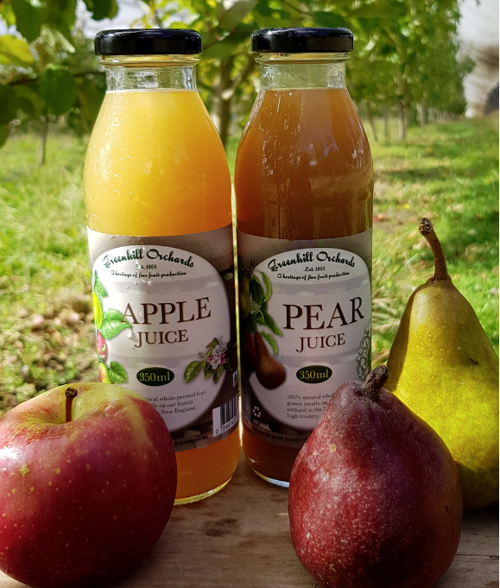

Your day will start with a trip to **Green Hill Orchards** in the district of Arding, arriving at 9am. There will be a talk on apple production and apple juice production with the opportunity to purchase juices if you wish.   
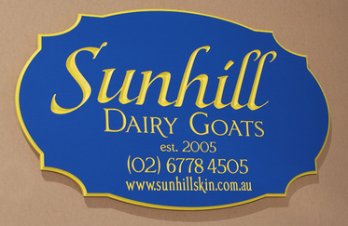 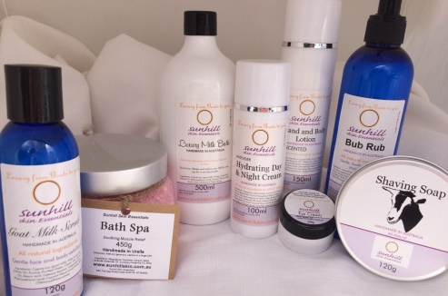 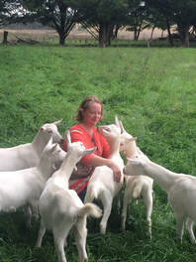

The tour will then progress to Sunhill Dairy Goats Farm, Uralla for a tour of a goat dairy, cheese making and tasting and gift shop for the opportunity to purchase products, including cheese and skin care range.

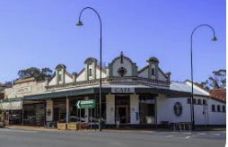 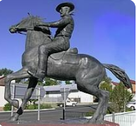 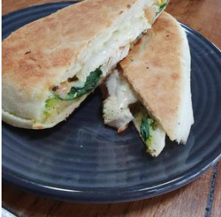

For lunch you will be taken to the beautiful town of ***Uralla***. Here you will have some free time to enjoy the local shops and have lunch before proceeding to the days final attraction.

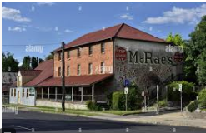Last stop for our Tour at 2.30pm is Uralla’s McCrossins Mill for a self-guided look at the Gallery and Museum, then at 3.30pm afternoon tea will be served at McCrossins Mill.It will be a great way to finish off the tour before heading back to the Armidale Bowling Club.