2024 New England Convention.
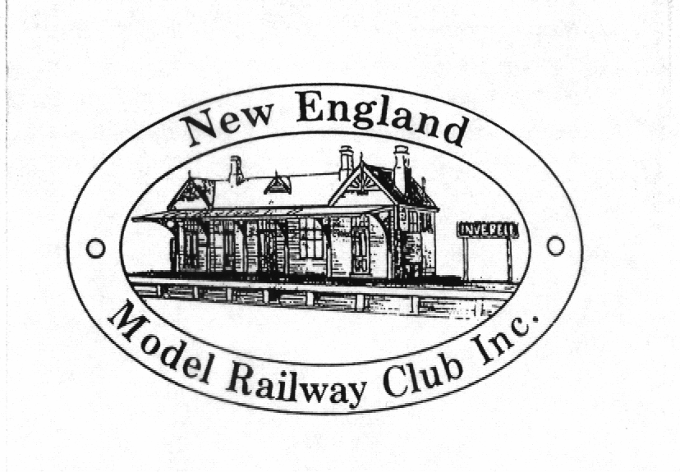

Armidale Bowling Club Armidale
16-17th November 2024

Dear Fellow Modeller,
This is an invitation to all railway modellers to attend the 2024 New England Convention. The convention will provide an opportunity to exchange and learn modelling ideas and techniques, plus catch up with some old friends and make some new ones.

The convention will be held at the Armidale Bowling Club, Dumaresq Street Armidale NSW. This convention is held outside of the large city areas, and is aimed at providing a convention for those who cannot make the trek to places such as Sydney, Melbourne or Brisbane.

The convention will be held over 2 days, commencing on Friday evening for registration, introduction and a get-to-know-you session, finishing on Sunday after lunch to see you on your way. There will be more information and registration on the New England Club website here. www.newenglandmodelrailwayclub.com

Presentations
There will be a number of different presentation sessions to choose from covering various aspects of railway modelling. These include, Operation, Scenery, Weathering, DCC, and Structures. Some of these presentations will only be run once so you will need to choose carefully.

Side Show Clinics
There will also be a number of “hands on” demonstrations on various aspects of railway modelling and scratch building etc. Some of these are Steam Cranes, Fast Tracks and DCC. These will be on-going throughout the weekend on an “as required” basis.

Layouts
There will be some new layouts or dioramas on display for modellers to inspect. These layouts are relatively new and have not been greatly exposed to the modelling public before, so they should be of great interest to all modellers.

Accommodation
Accommodation is available at several excellent locations within Armidale and there are 3 or 4 motels within walking distance of the venue. A list of suitable accommodation is on the club website and also included here.

Convention Wagon Decals
In the past we have offered a commemorative convention wagon. Due to the rising costs, this year we are offering a commemorative decal set for modellers to affix to their own wagon of choice. You can order your special wagon decals on the registration form.

Convention Notes
This year all convention notes will be supplied on a USB drive. If, however you wish to obtain a printed copy of the notes there will be a cost of $40.00 per copy and must be ordered at registration time. See registration form.

Partners Programme
This year there will be a non-rail partners programme that will take you to various tourist locations in the district such as an Apple Orchard, A Goat Farm, and exploring the boutique shops and café’s of Uralla. (Lunch at own expense) This year we have been restricted to a smaller bus so it will be first in best dressed. Alternatively, there is the opportunity to tour Armidale or check out the great shopping in the area. There are also a number of waterfalls along the waterfall way to visit.

Trade Stands
There will also be a small group of commercial traders represented. Some specialized and hard to get items will be available, and maybe some new products will be released or on display. Some of those who will attend are: Andian Models, Mechanical Branch Models, Modellers Warehouse, Gwydir Valley Models, IDR Models, Casula Hobbies, Broad Gauge Models, SDS Models and Keiran Ryan Models.

Modelling Competition
This year there will be a modelling competition for three different categories. These are Locomotives, Rollingstock and Dioramas. The judging will be carried out by some prominent judges. (see separate form for details)

Model Display
All attendees are encouraged to contribute to a model display. Models can be anything railway related. Partially completed models are also encouraged. Models can be kit built, scratchbuilt, detailed ready to run models of locomotives, rollingstock, structures, dioramas or modules.

Convention Dinner
There will be a Banquet Dinner on the Saturday night and attendees are encouraged to include spouses and partners as there will be some gifts and prizes for the Ladies as well as the Guys. There will also be a noted after dinner guest speaker.

Cost
The cost for the two days which includes convention registration, morning and afternoon teas and lunch on both days, will be $220.00 per attendee and there will be a sizeable discount for those who register early (see registration form)

Please complete the registration form and send it with your payment to arrive no later than Friday 25th October 2024.
You can’t afford to miss this great event.
Register Now! Application form enclosed.
If you need any additional information, please do not hesitate to contact me on Phone No. (02) 6772 0251 or 0413 016 086

We look forward to meeting you at Armidale in October at what should be a truly successful New England Convention.

Yours in Modelling

Geoff Yeomans
President.

